**Cityview360**

**Introduction**

**Explain About**

1)General Architecture Or Block Diagram Or Flow Diagram Of The Domain

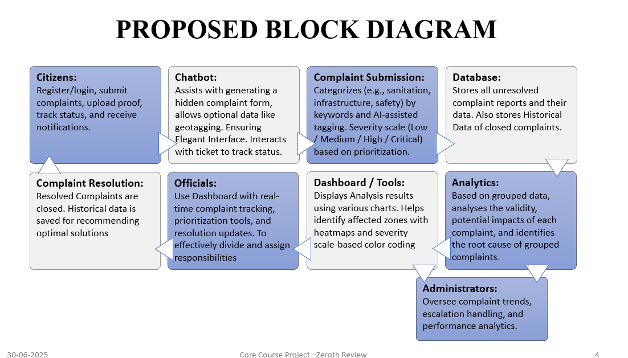

---------------------------------------------------------------------------------------------------------------------------------------

2) Explain About The Application

*Our Solution Is A Web-Based Real-Time Complaint Analysis And Resolution Platform Designed To Improve How Urban Public Utility Issues Are Reported, Tracked, And Resolved. It Empowers Citizens To Easily Log Complaints Using Text,Images,Vids And Documents, While Allowing Them To Track Progress And Receive Timely Updates. Government Officials Are Equipped With An AI-Powered Dashboard That Helps Them Prioritize Issues Based On Severity, Location, And Escalation Status. The Platform Includes Features Such As Automated Categorization, Geo-Tagging, Predictive Analytics, And A Dynamic Heatmap Interface To Visualize Complaint Trends. A Smart Escalation System Ensures That Unresolved Issues Are Automatically Flagged And Escalated To Higher Authorities. With Additional Tools Like Multilingual Support, Accessibility Features, Offline Mode, And Community Gamification, This Solution Creates A Transparent, Efficient, And Citizen-Centric Ecosystem For Managing Urban Utility Complaints*

---------------------------------------------------------------------------------------------------------------------------------------

3) Discuss About The Problem Statement In Detail

**Urban Areas Are Facing Increasing Challenges In Managing Public Utilities Such As Water, Electricity, Sanitation, And Waste Disposal. While Citizens Frequently Report Issues, These Complaints Are Often Scattered Across Various Platforms And Go Unanalyzed In Real Time. This Leads To Delayed Responses, Inefficient Resource Allocation, And Growing Public Dissatisfaction.**

**Write up:**

**CV360-**

**CV360 allows citizens to report complaints with detailed information, including multimedia evidence, and track their resolution progress. Government officials can then monitor, prioritize, and address these complaints based on severity, location, and escalation status, fostering transparency and accountability in the process. The system incorporates smart escalation mechanisms and data-driven insights to improve responsiveness and resource allocation.**

**Key Features**

**The platform is built around several core features designed to streamline the complaint resolution process and enhance citizen engagement.**

**User Roles & Access**

**The platform supports distinct user roles with varying levels of access and functionality:**

* **Citizens (Society Members): Citizens can register and log in to the platform to submit complaints, providing detailed descriptions, uploading supporting evidence (images, videos, and documents), and tracking the status of their submitted complaints. They also receive notifications regarding updates and resolutions.**
* **Officials: Government officials have access to a dedicated dashboard that provides real-time tracking of complaints, prioritization tools to manage workload effectively, and the ability to update the resolution status of complaints.**
* **Admin/Supervisors: Administrators and supervisors oversee overall complaint trends, manage escalation handling, and analyze performance metrics to identify areas for improvement and ensure the platform's effectiveness.**

**Complaint Submission & Categorization**

**The complaint submission process is designed to be user-friendly and comprehensive:**

* **Dropdown Categories: Citizens can categorize their complaints using predefined dropdown options (e.g., sanitation, infrastructure, safety). The system also incorporates AI-assisted tagging to suggest relevant categories based on the complaint description, improving accuracy and consistency.**
* **Geotagging: Users have the option to geotag their complaints, providing precise location mapping for efficient identification and resolution of location-specific issues.**
* **Severity Scale: A severity scale (Low/Medium/High/Critical) allows citizens to indicate the urgency and impact of their complaints, enabling officials to prioritize accordingly.**

**Smart Escalation System**

**The platform incorporates a smart escalation system to ensure timely resolution of complaints:**

* **Stage 1: Yellow Flag: If a complaint remains unresolved after 45 days, a Yellow Flag is triggered, sending a warning notification to the assigned official.**
* **Stage 2: Red Flag: If the complaint remains unresolved for an additional 15 days (60 days total), a Red Flag is triggered. This escalates the complaint to higher authorities and increases public visibility, promoting accountability.**
* **Automated Alerts: Automated SMS and email alerts are sent to officials at each escalation stage, ensuring they are promptly notified of overdue complaints.**

**Dynamic Dashboard for Officials**

**Government officials have access to a dynamic dashboard that provides valuable insights and tools:**

* **Heatmaps: Heatmaps visually represent complaint density by area, allowing officials to identify hotspots and allocate resources effectively.**
* **Trend Analysis: The dashboard provides trend analysis, such as identifying a significant increase in waterlogging complaints in a specific zone, enabling proactive measures to address emerging issues.**
* **"Boil-Up Rate" Metric: A "Boil-Up Rate" metric highlights frequently ignored issues, drawing attention to systemic problems that require immediate attention.**

**Transparency & Public Engagement**

**The platform promotes transparency and encourages public engagement:**

* **Public Dashboard: A public dashboard displays anonymous data showcasing the ratio of resolved versus pending complaints, providing citizens with an overview of the government's responsiveness.**
* **Citizen Upvoting: Citizens can upvote widespread issues to highlight community priorities, allowing officials to focus on the most pressing concerns.**
* **Official Response Timelines & Resolution Proof: The platform displays official response timelines and resolution proof (e.g., before/after photos) to demonstrate accountability and build trust with citizens.**

**Technology Stack**

**The platform can be built using a combination of modern web technologies. A possible stack includes:**

* **Frontend: React, Angular, or Vue.js for a responsive and interactive user interface.**
* **Backend: Node.js with Express, Python with Django/Flask, or Java with Spring Boot for handling API requests and business logic.**
* **Database: PostgreSQL or MySQL for storing complaint data, user information, and system configurations.**
* **Cloud Platform: AWS, Google Cloud, or Azure for hosting and scalability.**
* **AI/ML: Integration with AI/ML services for automated tagging and trend analysis.**

**Benefits**

**The implementation of this digital platform offers numerous benefits:**

* **Improved Citizen Engagement: Provides a convenient and accessible channel for citizens to report issues and track their resolution.**
* **Enhanced Government Responsiveness: Enables officials to prioritize and address complaints efficiently, leading to faster resolution times.**
* **Increased Transparency & Accountability: Promotes transparency through public dashboards and resolution proof, fostering trust between citizens and the government.**
* **Data-Driven Decision Making: Provides valuable data insights for resource allocation and proactive problem-solving.**
* **Reduced Bureaucracy: Streamlines the complaint resolution process, reducing paperwork and administrative overhead.**

**Conclusion**

**This digital platform represents a significant step towards creating a more responsive, transparent, and accountable government. By empowering citizens to report issues easily and providing officials with the tools to address them effectively, the platform can contribute to a better quality of life for all members of the society. The smart escalation system, dynamic dashboards, and focus on public engagement ensure that issues are addressed promptly and that the government remains accountable to its citizens.**

**Note: All Content Should Be In Times New Roman**

**Spacing Is 1.0**

**Title Font -14, Capitalize Each Word**

**Other Content Font-10**